Answer No 1:
- Hard links: a hard link is a pointer to the file's i-node. i.e on same file system.
Soft links (symbolic links): a soft link, also called symbolic link, is a file that contains the name of another file. We can then access the contents of the other file through that name. That is, a symbolic link is like a pointer to the pointer to the file's contents.(i.e on different file system).
- This statement tells your system to run the .logout script whenever it receives a zero ( 0 ) signal, which occurs automatically when you log out.
- i-nodes
A Unix file is described by an information block called an i-node. There is an i-node on disc for every file on the disc and there is also a copy in kernel memory for every open file. All the information about a file, other than its name, is stored in the i-node. Diagram:
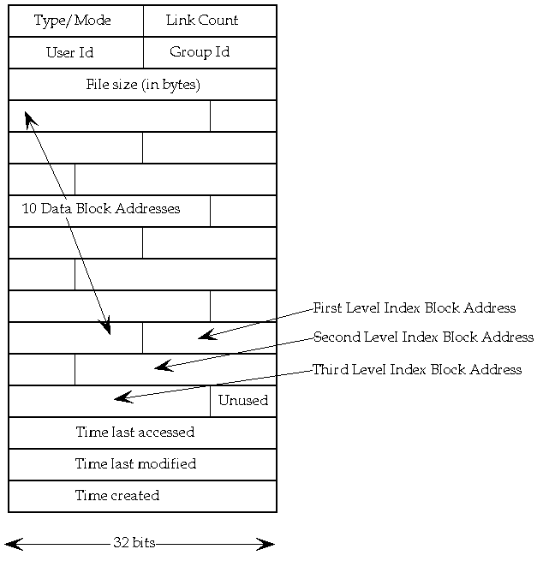
- The five extra information are:
- File access and type information, collectively known as the mode.
- File ownership information.
- Time stamps for last modification, last access and last mode modification.
- Link count.
- File size in bytes.
- Addresses of physical blocks.
- A pipe is a one-way connection between two related commands. One command writes its output to the pipe, and the other process reads its input from the pipe. When two or more commands are connected by the pipe (|) operator, they form a pipeline.
A filter is a command that reads its standard input, transforms that input, and then writes the transformed input to standard output. Filters are typically used as intermediate commands in pipelines - that is, they are connected by a pipe (|) operator

(a) ~c : change the local directory.
(b) ~t : copy a file from the remote host to a file on the local host.
( c ) ~< : copy a file from the remote host to a file on the local host.
(d ) ~p : copy a file from the local host to a file on the remote host.
(e ) ~> : copy a file from the local host to a file on the remote host.
- (i) Execution based on success.
(ii) Execution based on failure.
(iii) Sequence statement.
(iv) Background process
- Rcp / usr/incomtax/deduct Finance:/usr/staff/overtime
- Ls | sort –r > a.txt
- Echo $SHELL , chsh
- Groups commands to run as a separate process in a subshell. (i.e) list the content of the directory account by creating a subshell and list the content of the current directory.
- The .cshrc login script sets up your C shell environment by defining variables and operating parameters for the local shell process. The .login script defines variables and operating parameters that you want executed at the beginning of your session, and that you want to be valid for all shell processes during the current login session.
- Cat /etc/passwd | grep “ksh” | sort | more.
- Export Overtime
- Make a long list, gather the repetitive r-x and count the number of lines.

Answer No2:
- Cu and tip.
- The cu command connect to a remote host that has a long-distance telephone number of 4930626. The -s option specifies a transmission rate of 300 baud.
- # uux "UTM!cat UTM!/u/doc/F1 UOM!/usr/doc/F2 > UTM!/u/doc/F3"
The uux command uses the operating system cat command to concatenate the /u/doc/F1 file located on host UTM, with the /usr/doc/F2 file located on host UOM. The result is placed in the /u/doc/F3 file on host UTM.
- UTM% uucp /usr/staff/IT UOM\!~uucp
Copy the /usr/staff/IT file from local host UTM to the ~uucp public directory on remote host UOM, making use of the C Shell.
- The three daemons that should be running are:
- Nfsd : The NFS daemon which services requests from the NFS clients.
- Mountd: The NFS mount daemon which carries out the requests that nfsd passes on to it.
- Rpcbind: This daemon allows NFS clients to discover which port the NFS server is using
- Mysort || rm mysort.tmp.
- (a) IP address assign to the name of a machine.
(b) Ip address of the gateway.
( c ) Ip address of the DNS.

- /bin is but one of many directories that contain applications and utilities. However, /bin typically contains utilities that are essential to system operation. Hence, the shells, file-manipulation commands such as cp and chmod, compression and decompression, and diagnostics reside in /bin.
- /sbin also contains utilities crucial to system operation and maintenance. However, the programs found in /sbin can be executed only by superusers—hence, "superuser-bin" or /sbin.
- /home contains a user's home directories. For instance, if your login name is joe, the directory /home/joe acts as your personal file repository.
- /tmp, or "temporary," is the system-wide scratch pad. Your Web server might stash session data files here, and other utilities use the space in /tmp for caching intermediate results. Files in /tmp are considered disposable.
- /lib is the coffer for essential system libraries. In modern UNIX, system libraries are typically shared, meaning that the libraries are not linked and included in each binary (which would waste space, at the least), but are loaded on demand when needed and shared by many applications at once. Hence, core applications and utilities installed with UNIX require the libraries in /lib to run, and you need at least a small handful of the libraries to create new executables from source code. All files here are vital, and the corruption or removal (whether intentional or accidental) of even one file can render a system useless.
- /usr is the umbrella for a great number of files. End-user applications—from editors, games, and interfaces, to system features—are here, as is the library of man pages along with much more. Chances are that if the file is useful but not mandatory for system operation, you'll find it in /usr.
- /var —short for "variable"—is the repository for files that typically grow in size over time. Mailboxes, log files, printer queues, and databases can be found in /var. It's commonplace also for Web sites to be kept in /var because a Web site tends to amass data preternaturally over time.

Answer No3:
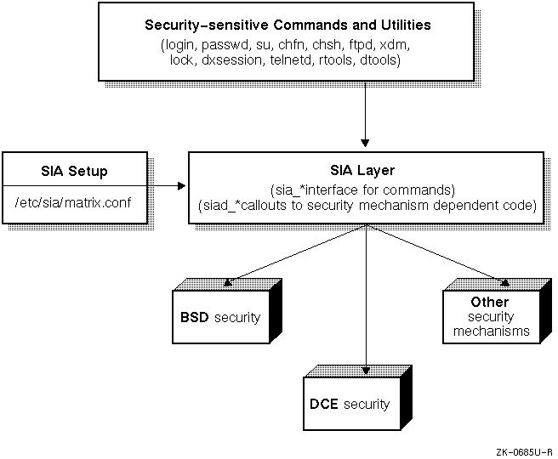
(ii)
- Install the layered security product as described in the product's installation procedure.
- Change directory to /etc/sia.
- Link the /etc/sia/matrix.conf file to the new matrix.conf file provided by the layered product using the ln -sf new_matrix.conf matrix.conf command.
- Reboot your system.
(iii) (a) The /etc/hosts.equiv file contains a list of host systems that are equivalent to your local host system. Users on equivalent hosts can log in to their accounts on the local host without typing a password. The user name on the remote and local host must be identical.
Equivalent hosts can be remote hosts or the local host. If the local host is listed in the /etc/hosts.equiv file, users logged in to the local host can remotely log in to their own accounts on the local host, without typing a password.
For security reasons, the /etc/hosts.equiv file does not allow a superuser logged in on a remote system to log in to the local host without typing a password.
Because the /etc/hosts.equiv file is a remote system's access key to your system, security-conscious system administrators leave this file empty or carefully restrict access to systems.
If the /etc/hosts.equiv file is empty, the only way a user on a remote host can log in to your account on the local host without typing a password is if the user's name is listed in your .rhosts file.
(b) .$HOME/ .rhosts.
The most common use of the $HOME/.rhosts file is to simplify remote logins between multiple accounts owned by the same user. If you have active accounts on more than one system, you may need to copy files from one account to the other or remotely log in to one account from the other. The \.rhosts file is ideally suited to this type of use.
(iv) The authentication subsystem verifys that users who log in to the system have the required password. It is the framework in which processes, protected subsystems, and the kernel work together to ensure that only authorized users and their processes gain access to the system.
The authentication subsystem uses and maintains the following security databases. These databases contain parameters and statistics for the system, for users, and for terminals.
- Protected Password database (prpasswd)
- System Defaults database (default)
- Terminal Control database (ttys)
- File Control database (files)
- Device Assignment database (devassign)
(v) # nm -Bn /vmunix | grep sp_insert_ir
(vi) # dbx /vmunix -k
Answer 4:
(1) HOME : Specifies the name of your login directory, the directory that becomes the current directory upon completion of a login. The cd command uses the value of HOME as its default value. HOME is set by the login command.
PATH : Specifies the directories through which your system should search to find and execute commands. The shell searches these directories in the order specified here. Usually, PATH is set in the .profile file.
SHELL : Specifies your default shell. This variable should be set and exported by your .profile file.
CDPATH : Specifies the directories that the cd command will search to find the specified argument to cd. If cd's argument is null, or if it begins with a slash (/), dot (.), or dot dot (..), then CDPATH is ignored. Usually, CDPATH is set in your .profile file.
MAILCHECK : Specifies in seconds how often the shell checks for mail (600 seconds is the default). If the value of this variable is set to 0, the shell checks for mail before displaying each prompt. MAILCHECK is usually set in your .profile file.
(2) Answers:

1) Need backslash before star in multiplication:
expr $height \* $width

2) Cannot have spaces in "area = ",
should be: "area="

3) area = 'expr $height \* $width'
should be with backquotes:
area = `expr $height \* $width`

(3) Answers:

1) echo "Hi user!" should be:
echo "Hi $user!"
2) Need spaces in if:
if [ $user = "utm" ]
3) Need then after if:
#!/bin/sh
user=`whoami`
if [ $user = "utm" ]
then
echo "Hi student!"
else
echo "Hi $user!"
fi

(4) Answers:

1) Need space after elif: elif [ $users > 1 ]

2) No ">=" and ">". Should be:
if [ $users -ge 4 ]

3) Need then after elif:
#!/bin/sh
users=`who | wc -l`
if [ $users -ge 4 ]
then
echo "Heavy load!"
elif [ $users -gt 1 ]
then
echo "Medium load"
else
echo 'Just me!'
fi

Question No5:
- The Logical Storage Manager (LSM) is an integrated, host-based disk storage management tool that protects against data loss, improves disk input/output (I/O) performance, and customizes the disk configuration. System administrators use LSM to perform disk management functions without disrupting users or applications accessing data on those disks.
- Diagram:

Volume Device Driver:
The LSM (volume device driver ) is an installable driver that maps the logical configuration of the system to the physical disk configuration. Although the volume device driver resides between the disk device and the applications, it maps the configuration transparently to the file systems, databases, and applications above it. Thus, applications do not need to be changed in order to access data on LSM volumes. The volume device driver implements striping or concatenation, read and write error handing, and mirroring in LSM configurations.

- Manages disk administration: Frees you from the task of partitioning disks and maintaining disk-space administration. However, LSM allows you to keep control over disk partitioning and space allocation, if desired.
Allows transparent disk configuration changes: Allows you to change the disk configuration without rebooting or otherwise interrupting users. Also allows routine administrative tasks, such as file system backup, while the system is in active use.
Stores large file systems: Enables multiple physical disks to be combined to form a single, larger logical volume.
Eases system management: Simplifies the management of disk configurations by providing convenient interfaces and utilities to add, move, replace, and remove disks.
Protects against data loss: Protects against data loss due to hardware malfunction by creating a mirror (duplicate) image of important file systems and databases.
Increases disk performance: Improves disk I/O performance through the use of striping, which is the interleaving of data within the volume across several physical disks.
Provides recovery from boot disk failure: Allows you to mirror the root file system and swap partition. By duplicating the disks that are critical to booting, LSM ensures that no single disk failure will leave your system unusable.

- The partitions on a physical device are mapped by a partition table called the disklabel. The disk's partitions and disk label have the following characteristics:
- The disk label maps a physical disk to a maximum of eight partitions that are labeled from a to h.
- Partition c covers the whole disk.
- The partitions can overlap each other.
- Each partition has an fstype attribute. If a partition is not in use, the fstype is unused. If a partition is in use, the fstype can have values such as 4.2BSD, AdvFS, swap, LSMsimp, LSMpubl, LSMpriv, or LSMnopriv.
- The disk label resides at block 0 of a physical device. For most devices, the default disk label is defined in /etc/disktab.
- You can modify an online disk label using the utility program /usr/sbin/disklabel.
- (a) Renaming a Disk: # voledit rename disk03 disk01.
(b) Reserving a Disk: By default, volassist operations allocate space from any disk that has free space:
# Volassist make vol 03 20m disk03.
Here 20 megabyte volume is being reserved on disk 03.
( c ) Removing a Disk:
  - Remove the disk from the disk group, by using voldg command:
Voldisk rmdisk disk01.
After removing the disk from the group, remove it from the LSM using the voldiskrm devname.
#voldisk rm rz9d here to remove rz9d from LSM control:
- Disabling a Disk: The Disk must be disable before moving the physical disk to another system: [ example to disable the device rz8 ( which has disk name, disk01 )
# voldg rmdisk disk01
# voldisk offline rz8

